Types of Association – Many-to-Many

📌 Definition:
# Source: AI Source: Provided by: [Data Path: Persons Table -> ID Column: 1, Name_En Column: Motasem Essam] -> From: [Chatgpt (GPT‑5 Mini)] on [12/9/2025]
Many-to-Many association is a relationship where multiple objects are associated with multiple other objects on both sides.

🧠 Simple idea:
# Source: AI Source: Provided by: [Data Path: Persons Table -> ID Column: 1, Name_En Column: Motasem Essam] -> From: [Chatgpt (GPT‑5 Mini)] on [12/9/2025]
Many-to-Many = “many ↔ many” 👨‍🎓↔📚↔👨‍🎓

🔍 Key characteristics:
# Source: AI Source: Provided by: [Data Path: Persons Table -> ID Column: 1, Name_En Column: Motasem Essam] -> From: [Chatgpt (GPT‑5 Mini)] on [12/9/2025]
- 🔗 Many objects ↔ many objects
- 🧩 Each object can relate to multiple others
- 🔄 No single ownership
- ⚙️ Usually implemented using an intermediate (join) structure

📌 Real-world examples:
# Source: AI Source: Provided by: [Data Path: Persons Table -> ID Column: 1, Name_En Column: Motasem Essam] -> From: [Chatgpt (GPT‑5 Mini)] on [12/9/2025]
- 👨‍🎓 Students ↔ Courses
- 🎬 Actors ↔ Movies
- 👨‍💻 Developers ↔ Projects
- 📚 Books ↔ Authors

📌 Example (Java-style):
# Source: AI Source: Provided by: [Data Path: Persons Table -> ID Column: 1, Name_En Column: Motasem Essam] -> From: [Chatgpt (GPT‑5 Mini)] on [12/9/2025]
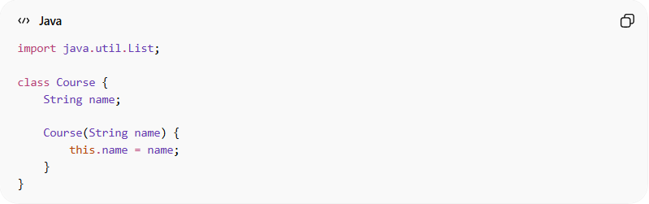
import java.util.List;

class Course {
String name;

Course(String name) {
this.name = name;
}
}
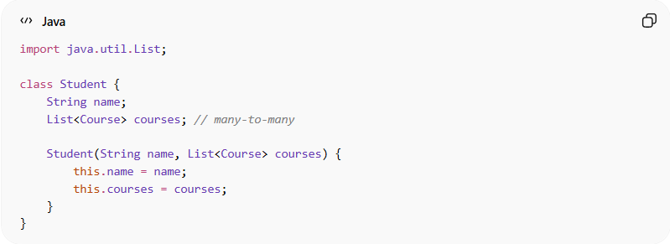
import java.util.List;

class Student {
String name;
List<Course> courses; // many-to-many

Student(String name, List<Course> courses) {
this.name = name;
this.courses = courses;
}
}

Usage:
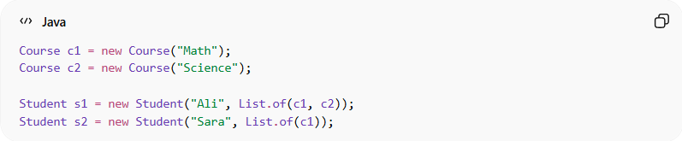
Course c1 = new Course("Math");
Course c2 = new Course("Science");

Student s1 = new Student("Ali", List.of(c1, c2));
Student s2 = new Student("Sara", List.of(c1));
👉
- One student takes many courses
- One course has many students

🔄 Relationship diagram:
# Source: AI Source: Provided by: [Data Path: Persons Table -> ID Column: 1, Name_En Column: Motasem Essam] -> From: [Chatgpt (GPT‑5 Mini)] on [12/9/2025]
Student ↔ Course
Student ↔ Course

⚙️ Important Note (Database View):
# Source: AI Source: Provided by: [Data Path: Persons Table -> ID Column: 1, Name_En Column: Motasem Essam] -> From: [Chatgpt (GPT‑5 Mini)] on [12/9/2025]
In databases, Many-to-Many is usually handled using a junction table:
Students ←→ Student_Course ←→ Courses

🎯 Why it is important:
# Source: AI Source: Provided by: [Data Path: Persons Table -> ID Column: 1, Name_En Column: Motasem Essam] -> From: [Chatgpt (GPT‑5 Mini)] on [12/9/2025]
- 🧩 Models complex real-world relationships
- 🔄 Highly flexible
- ⚙️ Essential in database design
- 🧠 Represents interconnected systems

🎯 Summary:
# Source: AI Source: Provided by: [Data Path: Persons Table -> ID Column: 1, Name_En Column: Motasem Essam] -> From: [Chatgpt (GPT‑5 Mini)] on [12/9/2025]
Many-to-Many association means multiple objects are connected to multiple other objects, forming a flexible and interconnected relationship.

